We can separate investors according to their horizon. Traders try to  
profit in the short term, usually within a day, and long-term investors  
buy a stock without the intent to sell it in the near future. This type  
of investment strategy is called BH (*buy and hold*). At the extreme,  
you buy a stock and hold it forever. The most famous spokesperson of BH  
is Warren Buffet, among many others.

Investing in the long run works for me because it doesn’t require much  
of my time. You just need to keep up with the quarterly and yearly  
financial reports of companies. You can easily do it as a side activity,  
parallel to your main job. You don’t need a lot of brain power to do it  
either, but it does require knowledge of accounting practices to  
understand all the material that is released by the company.

I read many books before starting to invest and one of the most  
interesting tables I’ve found portrays the relationship between  
investment horizon and profitability. The idea is that the more time you  
hold a stock (or index), higher the chance of a profit. The table,  
originally from Taleb’s *Fooled by Randomness*, is as follows.

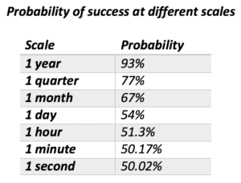

My problem with the table is that it seems pretty off. My experience  
tells me that a 67% chance of positive return every month seems  
exaggerated. If that was the case, making money in the stock market  
would be easy. Digging deeper, I found out that the data behind the  
table is simulated and, therefore, doesn’t really give good an estimate  
about the improvement in the probability of profits as a function of the  
investment horizon.

As you probably suspect, I decided to tackle the problem using real data  
and R. A simple “fct_invest_horizon.R”  
that will grab data, simulate investments of different horizons many  
times and plot the results. Let’s try it for the SP500 index:

#“fct_invest_horizon.R”

====================

sample.horizon <- function(price.vec, n.horizon, n.sim = 1000, rf.year = 0.0) {

#cat(paste0('\nSimulating n.horizon = ', n.horizon))

require(dplyr)

rf_dailly <- ((1+rf.year)^(1/255))^n.horizon

n.row <- length(price.vec)

df.out <- data_frame()

for (i.sim in 1:n.sim) {

idx.1 <- sample(1:(n.row-n.horizon), 1)

idx.2 <- idx.1 + n.horizon

df.out <- bind_rows(df.out, data_frame(n.horizon = n.horizon/255,

test = price.vec[idx.2] > price.vec[idx.1]*rf_dailly,

ret = price.vec[idx.2]/price.vec[idx.1] -1))

}

return(df.out)

}

get.figs.invest.horizon <- function(ticker.in, first.date = '1950-01-01',

last.date = Sys.Date(), max.horizon = 10, n.points = 25,

rf.year = 0) {

require(BatchGetSymbols)

require(purrr)

require(ggplot2)

require(scales)

my.df <- BatchGetSymbols(tickers = ticker.in,

first.date = first.date,

last.date = Sys.Date(), thresh.bad.data = 0.1)[[2]]

my.df <- na.omit(my.df)

my.l <- map2(list(my.df$price.adjusted),

seq(1, max.horizon, length.out = n.points), sample.horizon, rf.year = rf.year)

df.res <- do.call(what = bind_rows, args = my.l) %>%

group_by(n.horizon) %>%

summarise(prob = sum(test)/n())

p1 <- ggplot(data = df.res, aes(x = n.horizon, y = prob)) +

geom_point() + geom_smooth() +

labs(x = 'Investment Horizon (years)', y = 'Chance of Profit',

title = paste0('Asset: ', ticker.in),

subtitle = paste0(min(my.df$ref.date), ' -> ', max(my.df$ref.date)) ) +

scale_y_continuous(labels=percent)

df.plot <- do.call(what = bind_rows, args = my.l)

p2 <- ggplot(data = df.plot, aes(x = factor(floor(n.horizon)), y = ret)) +

geom_boxplot() +

labs(x = 'Investment Horizon (Years)',

y = 'Distribution of Returns',

title = paste0('Asset: ', ticker.in),

subtitle = paste0(min(my.df$ref.date), ' -> ', max(my.df$ref.date)) ) +

scale_y_continuous(labels=percent)

return(list(p1 = p1, p2 = p2))

}

==========================================

source('fct_invest_horizon.R')

my.ticker <- '^GSPC' # ticker from yahoo finance

max.horizon = 255*50 # 50 years

first.date <- '1950-01-01'

last.date <- Sys.Date()

n.points <- 50 # number of points in figure

rf.year <- 0 # risk free return (or inflation)

l.out <- get.figs.invest.horizon(ticker.in = my.ticker,

first.date = first.date,

last.date = last.date,

max.horizon = max.horizon,

n.points = n.points,

rf.year = rf.year)

##

## Running BatchGetSymbols for:

## tickers = ^GSPC

## Downloading data for benchmark ticker | Found cache file

## ^GSPC | yahoo (1|1) | Found cache file - Looking good!

print(l.out$p1)

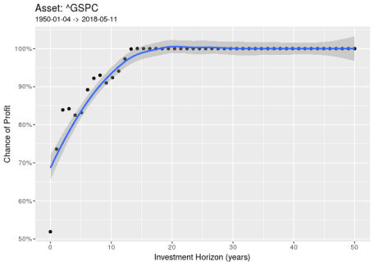

print(l.out$p2)

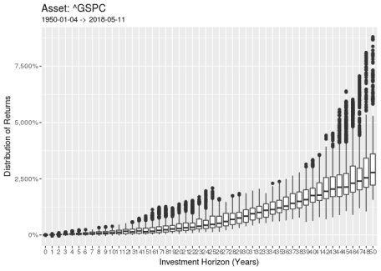

As we can see, the data doesn’t lie. As the investment horizon  
increases, the chances of a positive return increases. This result  
suggests that, if you invest for more than 13 years, it is very unlikely  
that you’ll see a negative return. When looking at the distribution of  
total returns by the horizon, we find that it increases significantly  
with time. Someone that invested for 50 years is likely to receive a  
2500% return on the investment.

With input input rf.year we can also set a desired rate of return.  
Let’s try it with 5% return per year, with is pretty standard for  
financial markets.

my.ticker <- '^GSPC' # ticker from yahoo finance

max.horizon = 255*50 # 50 years

first.date <- '1950-01-01'

last.date <- Sys.Date()

n.points <- 50 # number of points in figure

rf.year <- 0.05 # risk free return (or inflation) - yearly

l.out <- get.figs.invest.horizon(ticker.in = my.ticker,

first.date = first.date,

last.date = last.date,

max.horizon = max.horizon,

n.points = n.points,

rf.year = rf.year)

##

## Running BatchGetSymbols for:

## tickers = ^GSPC

## Downloading data for benchmark ticker | Found cache file

## ^GSPC | yahoo (1|1) | Found cache file - Got it!

print(l.out$p1)

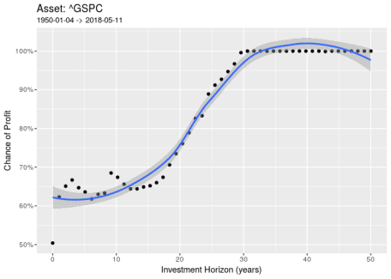

As expected, the curve of probabilities has a lower slope, meaning that  
you need more time investing in the SP500 index to guarantee a return of  
more than 5% a year.

Now, let’s try the same setup for Berkshire stock (BRK-A). This is  
Buffet’s company and looking at its share price we can have a good  
understanding of how successful Buffet has been as a BH (*buy and hold*)  
investor.

my.ticker <- 'BRK-A' # ticker from yahoo finance

max.horizon = 255*25 # 50 years

first.date <- '1980-01-01'

last.date <- Sys.Date()

n.points <- 50 # number of points in figure

rf.year <- 0.05 # risk free return (or inflation) - yearly

l.out <- get.figs.invest.horizon(ticker.in = my.ticker,

first.date = first.date,

last.date = last.date,

max.horizon = max.horizon,

n.points = n.points,

rf.year = rf.year)

##

## Running BatchGetSymbols for:

## tickers = BRK-A

## Downloading data for benchmark ticker | Found cache file

## BRK-A | yahoo (1|1) | Found cache file - OK!

print(l.out$p1)

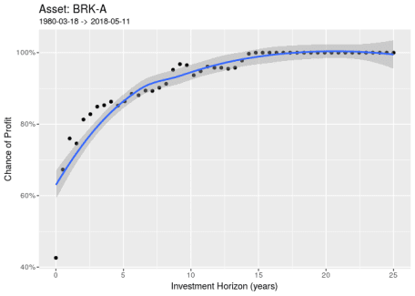

print(l.out$p2)

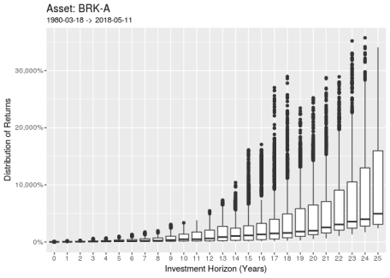

Well, needless to say that, historically, Buffet has done very well in  
his investments! If you bought the stock and kept it for more 1 year,  
there is a 70% chance that you got a profit on your investment.